32. Your company uses Azure DevOps with branch policies configured.  
Which of the following is TRUE with regards to branch policies? (Choose all that apply.)

* A. It enforces your team's change management standards.
* B. It controls who can read and update the code in a branch.
* C. It enforces your team's code quality.
* D. It places a branch into a read-only state.

37. You have been tasked with making sure that you are able to modify the operating system security configurations via Azure Security Center.  
To achieve your goal, you need to have the correct pricing tier for Azure Security Center in place.  
Which of the following is the pricing tier required?

* A. Advanced
* B. Premium
* C. Standard

38. 1. Your company's Azure subscription is linked to their Azure Active Directory (Azure AD) tenant.  
After an internally developed application is registered in Azure AD, you are tasked with making sure that the application has the ability to access Azure Key Vault secrets on application the users' behalf.  
Solution: You configure a delegated permission with admin consent.  
Does the solution meet the goal?

* B. No

1. You need to create an app registration
2. In the API permission add 'Azure Key Vault' permission, select 'user_impersonation'

3- Both applicationId and objectId must be specified in the access policy.

38.2. Solution: You configure a delegated permission with no admin consent.  
Does the solution meet the goal?

* A. Yes

Just register an Azure AD App then go to API Permissions and select Azure Key Vault, you will find a single permission to add "user_impersonation" under Delegated Permissions and Admin Consent is not required.

40. You need to consider the underlined segment to establish whether it is accurate.  
Your Azure Active Directory Azure (Azure AD) tenant has an Azure subscription linked to it.  
Your developer has created a mobile application that obtains Azure AD access tokens using the OAuth 2 implicit grant type.  
The mobile application must be registered in Azure AD.  
You require a redirect URI from the developer for registration purposes.  
Select `No adjustment required` if the underlined segment is accurate. If the underlined segment is inaccurate, select the accurate option.

* A. No adjustment required

11.

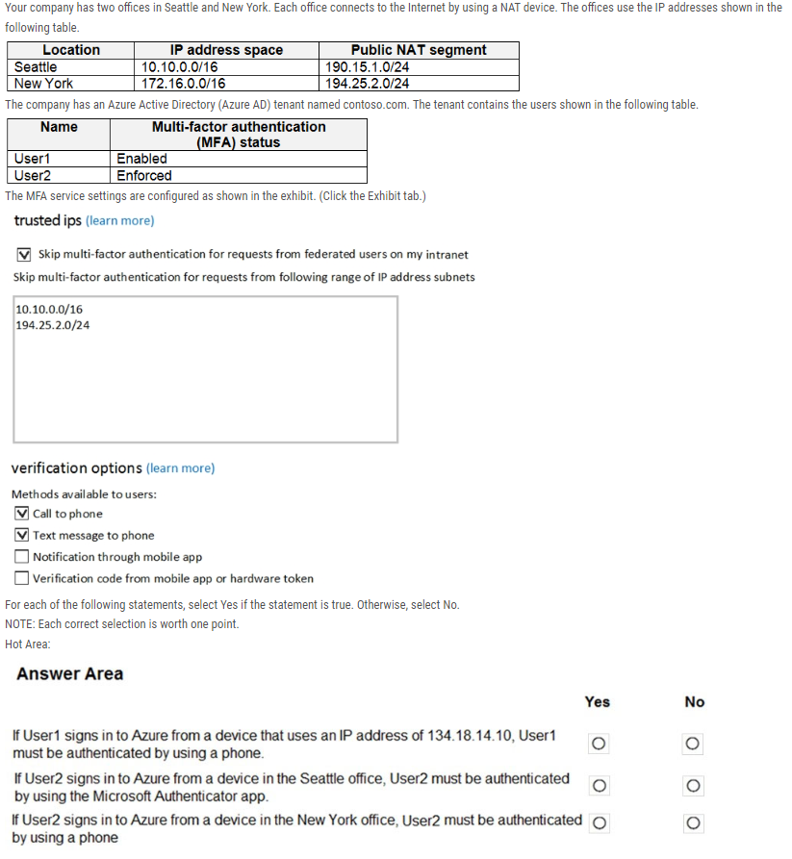

Yes – No – No

18. You create an Azure subscription with Azure AD Premium P2.  
You need to ensure that you can use Azure Active Directory (Azure AD) Privileged Identity Management (PIM) to secure Azure AD roles.  
Which three actions should you perform in sequence? To answer, move the appropriate actions from the list of actions to the answer area and arrange them in the correct order.

C: > Consent to PIM

> Verify your identity by using multi-factor authentication (MFA)

> Sign up PIM for Azure AD roles

21.

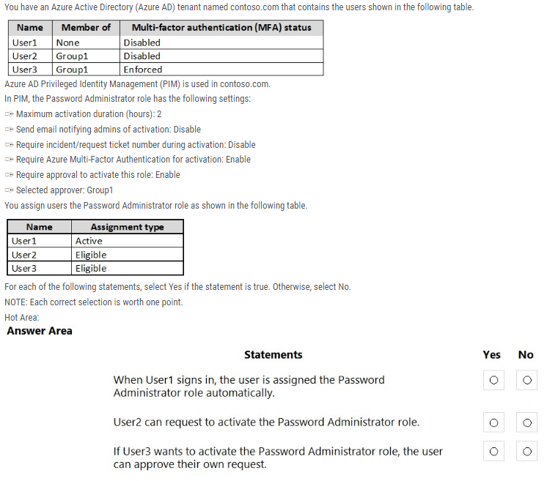

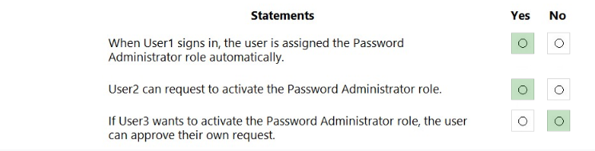

22.

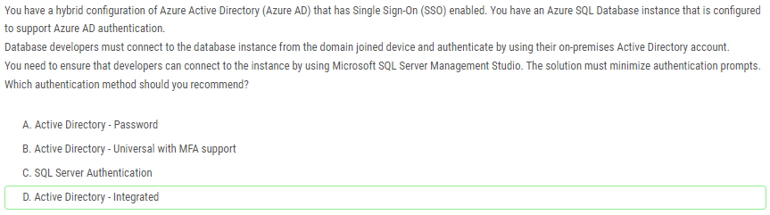

23.

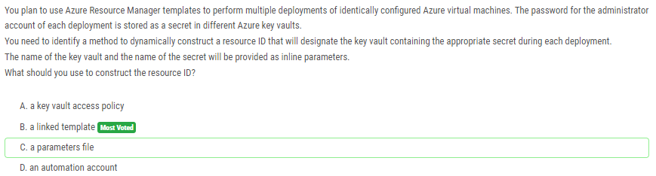

27.!

34.

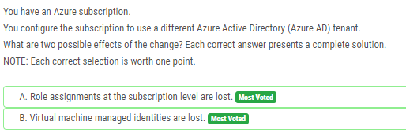

36. You have an Azure subscription that contains virtual machines.   
You enable just in time (JIT) VM access to all the virtual machines.  
You need to connect to a virtual machine by using Remote Desktop.  
What should you do first?

* B. From Azure Active Directory (Azure AD) Privileged Identity Management (PIM), activate the Owner role for the virtual machine.
* C. From the Azure portal, select the virtual machine, select Connect, and then select Request access.

37.!!

39. You have an Azure Active Directory (Azure AD) tenant named contoso.onmicrosoft.com.  
The User administrator role is assigned to a user named Admin1.  
An external partner has a Microsoft account that uses the user1@outlook.com sign in.  
Admin1 attempts to invite the external partner to sign in to the Azure AD tenant and receives the following error message: `Unable to invite user user1@outlook.com Generic authorization exception.`  
You need to ensure that Admin1 can invite the external partner to sign in to the Azure AD tenant.  
What should you do?

* A. From the Roles and administrators blade, assign the Security administrator role to Admin1.
* D. From the Users blade, modify the External collaboration settings.

44.You have an Azure subscription that contains an Azure Active Directory (Azure AD) tenant and a user named User1.  
The App registrations settings for the tenant are configured as shown in the following exhibit.  
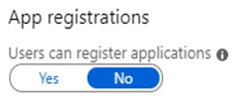  
You plan to deploy an app named App1.  
You need to ensure that User1 can register App1 in Azure AD. The solution must use the principle of least privilege.  
Which role should you assign to User1?

* A. App Configuration Data Owner for the subscription
* B. Managed Application Contributor for the subscription
* C. Cloud application administrator in Azure AD
* D. Application developer in Azure AD

13.1. Your Company's Azure subscription includes a virtual network that has a single subnet configured.  
You have created a service endpoint for the subnet, which includes an Azure virtual machine that has Ubuntu Server 18.04 installed.  
You are preparing to deploy Docker containers to the virtual machine. You need to make sure that the containers can access Azure Storage resources and Azure  
SQL databases via the service endpoint.  
You need to perform a task on the virtual machine prior to deploying containers.

2.Solution: You install the container network interface (CNI) plug-in.  
Does the solution meet the goal?

* A. Yes

16.Your company makes use of Azure Active Directory (Azure AD) in a hybrid configuration. All users are making use of hybrid Azure AD joined Windows 10 computers.  
You manage an Azure SQL database that allows for Azure AD authentication.  
You need to make sure that database developers are able to connect to the SQL database via Microsoft SQL Server Management Studio (SSMS). You also need to make sure the developers use their on-premises Active Directory account for authentication. Your strategy should allow for authentication prompts to be kept to a minimum.  
Which of the following is the authentication method the developers should use?

* B. Azure Multi-Factor authentication.
* C. Active Directory integrated authentication.

17.You have been tasked with enabling Advanced Threat Protection for an Azure SQL Database server.  
Advanced Threat Protection must be configured to identify all types of threat detection.  
Which of the following will happen if when a faulty SQL statement is generate in the database by an application?

* B. A Vulnerability to SQL injection alert is triggered.

20.You are in the process of creating an Azure Kubernetes Service (AKS) cluster. The Azure Kubernetes Service (AKS) cluster must be able to connect to an Azure  
Container Registry.  
You want to make sure that Azure Kubernetes Service (AKS) cluster authenticates to the Azure Container Registry by making use of the auto-generated service principal.  
Solution: You create an Azure Active Directory (Azure AD) role assignment.  
Does the solution meet the goal?

* A. Yes - When you create an AKS cluster, Azure also creates a service principal to support cluster operability with other Azure resources. You can use this auto-generated service principal for authentication with an ACR registry. To do so, you need to create an Azure AD role assignment that grants the cluster's service principal access to the container registry.

22. You have been tasked with delegate administrative access to your company's Azure key vault.  
You have to make sure that a specific user can set advanced access policies for the key vault. You also have to make sure that access is assigned based on the principle of least privilege.  
Which of the following options should you use to achieve your goal?

C. Azure AD Privileged Identity Management (PIM)

23.You have been tasked with delegate administrative access to your company's Azure key vault.  
You have to make sure that a specific user is able to add and delete certificates in the key vault. You also have to make sure that access is assigned based on the principle of least privilege. Which of the following options should you use to achieve your goal?

A. A key vault access policy

24.You have an Azure virtual machine that runs Windows Server R2.  
You plan to deploy and configure an Azure Key vault, and enable Azure Disk Encryption for the virtual machine. Which of the following is TRUE with regards to Azure Disk Encryption for a Windows VM?

B. It is supported for standard tier VMs. - Azure Disk Encryption is not available on Basic, A-series VMs, or on virtual machines with a less than 2 GB of memory.

26.You need to consider the underlined segment to establish whether it is accurate.  
You have configured an Azure Kubernetes Service (AKS) cluster in your testing environment.  
You are currently preparing to deploy the cluster to the production environment.  
After disabling HTTP application routing, you want to replace it with an application routing solution that allows for reverse proxy and TLS termination for AKS services via a solitary IP address.  
You must create an AKS Ingress controller.  
Select `No adjustment required` if the underlined segment is accurate. If the underlined segment is inaccurate, select the accurate option.

* A. No adjustment required. - Azure Ingress Controller is used to establish a reverse proxy

27. You want to gather logs from a large number of Windows Server 2016 computers using Azure Log Analytics.  
You are configuring an Azure Resource Manager template to deploy the Microsoft Monitoring Agent to all the servers automatically.  
Which of the following should be included in the template? (Choose all that apply.)

* A. WorkspaceID
* C. WorkspaceKey

1.Your company has deployed a system onto their Azure environment. The system consists of an application hosted via the Azure Web App service. The application connects to a database hosted on the Azure SQL database service. You have to implement the following requirement

a) Ensure that the data within a column named SSN within a table is encrypted. Only the application should be allowed to decrypt the data.

b) The application must make use of a managed identity to get the keys required for the decryption process.

C: Always encrypted using Key vault

2.Your company has deployed a system onto their Azure environment. The system consists of an application hosted via the Azure Web App service. The application connects to a database hosted on the Azure SQL database service. You have to implement the following requirement

a) Ensure that the data within a column named SSN within a table is encrypted. Only the application should be allowed to decrypt the data.

b) The application must make use of a managed identity to get the keys required for the decryption process.

Which of the following needs to be configured to ensure that the application can retrieve the keys?

C: Configure an access policy in the Azure Key Vault.

3. Can Security Admin role delegate access to another user for appvault?

C: No (It does not provide any sort of permissions over the key vault.)

4.Can User Access Administrator role delegate access to another user for appvault?

C: Yes

7. Your company recently created an Azure subscription.  
You have been tasked with making sure that a specified user is able to implement Azure AD Privileged Identity Management (PIM).  
Which of the following is the role you should assign to the user?

* A. The Global administrator role / Privileged Role Administrator

8. Your company has an Active Directory forest with a single domain, named weylandindustries.com. They also have an Azure Active Directory (Azure AD) tenant with the same name.  
You have been tasked with integrating Active Directory and the Azure AD tenant. You intend to deploy Azure AD Connect.  
Your strategy for the integration must make sure that password policies and user logon limitations affect user accounts that are synced to the Azure AD tenant, and that the amount of necessary servers are reduced.  
8.1.Solution: You recommend the use of pass-through authentication and seamless SSO with password hash synchronization.  
Does the solution meet the goal?

C: Yes

You have been tasked with configuring an access review, which you plan to assigned to a new collection of reviews. You also have to make sure that the reviews can be reviewed by resource owners.  
You start by creating an access review program and an access review control.  
You now need to configure the Reviewers.  
Which of the following should you set Reviewers to?

* C. Group Owners.

Your company recently created an Azure subscription. You have, subsequently, been tasked with making sure that you are able to secure Azure AD roles by making use of Azure Active Directory (Azure AD) Privileged Identity Management (PIM).  
Which of the following actions should you take FIRST?

* B. You should consent to Azure Active Directory (Azure AD) Privileged Identity Management (PIM).

You need to consider the underlined segment to establish whether it is accurate.  
You have been tasked with creating a different subscription for each of your company's divisions. However, the subscriptions will be linked to a single Azure Active Directory (Azure AD) tenant.  
You want to make sure that each subscription has identical role assignments.  
You make use of Azure AD Privileged Identity Management (PIM).  
Select `No adjustment required` if the underlined segment is accurate. If the underlined segment is inaccurate, select the accurate option.

* A. Blueprints

49. Your network contains an on-premises Active Directory domain named adatum.com that syncs to Azure Active Directory (Azure AD). Azure AD Connect is installed on a domain member server named Server1.  
You need to ensure that a domain administrator for the adatum.com domain can modify the synchronization options. The solution must use the principle of least privilege.  
Which Azure AD role should you assign to the domain administrator?

* A. Security administrator
* B. Global administrator
* C. User administrator

Azure AD Global Administrator account: used to create the Azure AD Connector account and configure Azure AD.

50. You have an Azure subscription that contains the users shown in the following table.  
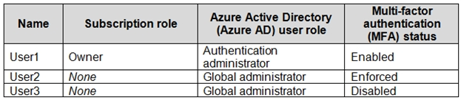  
Which users can enable Azure AD Privileged Identity Management (PIM)?

* A. User2 and User3 only **Most Voted**
* B. User1 and User2 only

Privileged Role Administrator or Global Administrator: role can manage assignments for other administrators.  
Global Administrators, Security Administrators, Global Readers, and Security Readers: can also view assignments to Azure AD roles in PIM.

58. You have an Azure subscription that contains the custom roles shown in the following table.  
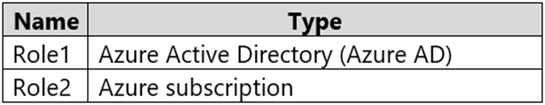  
In the Azure portal, you plan to create new custom roles by cloning existing roles. The new roles will be configured as shown in the following table.  
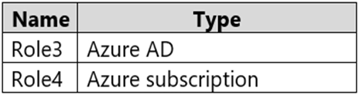  
Which roles can you clone to create each new role? To answer, select the appropriate options in the answer area.

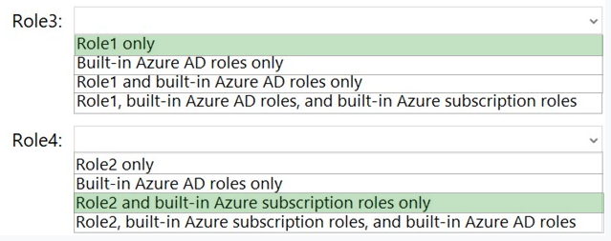

Built-in AD roles can't be cloned, but built-in subscription roles can be. Custom roles of either type can be cloned.

59. You have an Azure subscription that contains the Azure Active Directory (Azure AD) resources shown in the following table.  
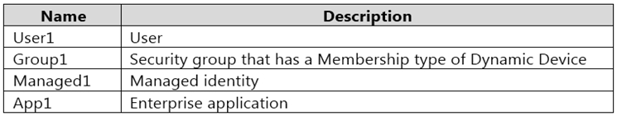  
You create the groups shown in the following table.  
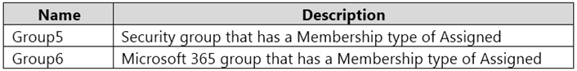  
Which resources can you add to Group5 and Group6? To answer, select the appropriate options in the answer area.

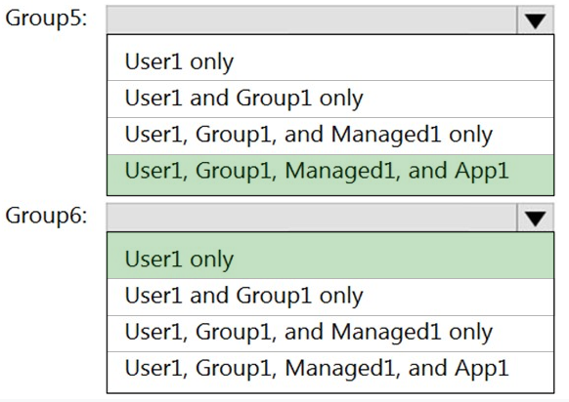

Members of a security group can include users, devices, other groups, and service principals, which define access policy and permissions.

Owners of a security group can include users and service principals.

Members of a Microsoft 365 group can only include users.

60.

You have an Azure Active Directory (Azure AD) tenant named contoso.com that contains three security groups named Group1, Group2, and Group3 and the users shown in the following table.  
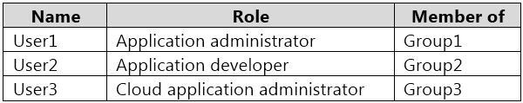  
Group3 is a member of Group2.  
In contoso.com, you register an enterprise application named App1 that has the following settings:  
✑ Owners: User1  
✑ Users and groups: Group2  
You configure the properties of App1 as shown in the following exhibit.  
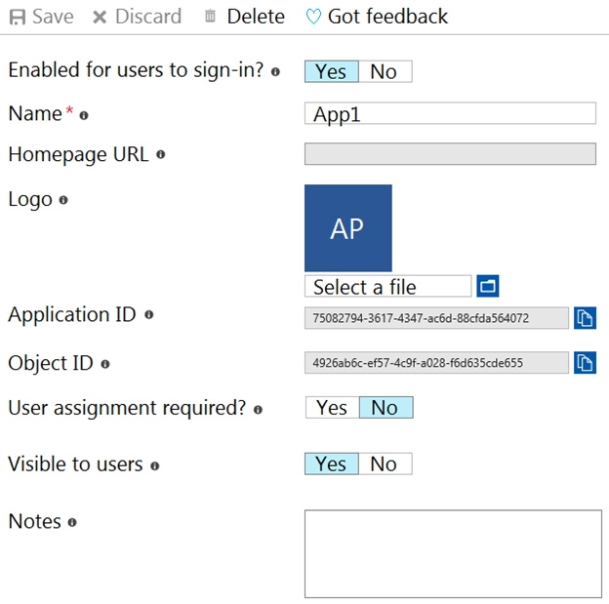

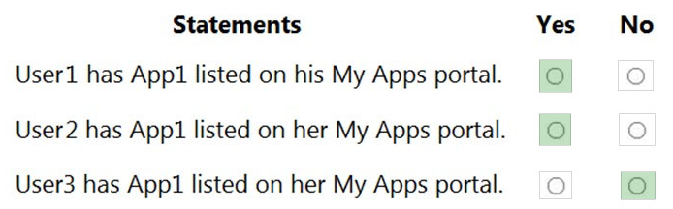

User 3 is in Group 3 that is a member of Group 2 but nested groups aren't supported in App assignments so only direct Group 2 membership will work.

61. You have an Azure subscription that contains the resources shown in the following table.  
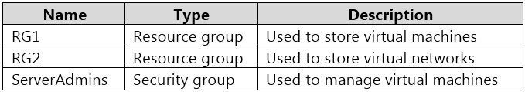  
You need to ensure that ServerAdmins can perform the following tasks:  
✑ Create virtual machines in RG1 only.  
✑ Connect the virtual machines to the existing virtual networks in RG2 only.  
The solution must use the principle of least privilege.  
Which two role-based access control (RBAC) roles should you assign to ServerAdmins? Each correct answer presents part of the solution.  
NOTE: Each correct selection is worth one point.

* A. a custom RBAC role for RG2
* B. the Network Contributor role for RG2
* C. the Contributor role for the subscription
* D. a custom RBAC role for the subscription
* E. the Network Contributor role for RG1
* F. the Virtual Machine Contributor role for RG1

62.

Your network contains an on-premises Active Directory domain named adatum.com that syncs to Azure Active Directory (Azure AD).  
The Azure AD tenant contains the users shown in the following table.  
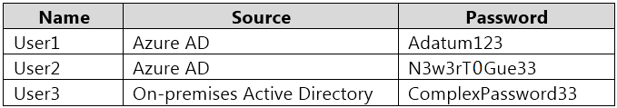  
You configure the Authentication methods `" Password Protection settings for adatum.com as shown in the following exhibit.  
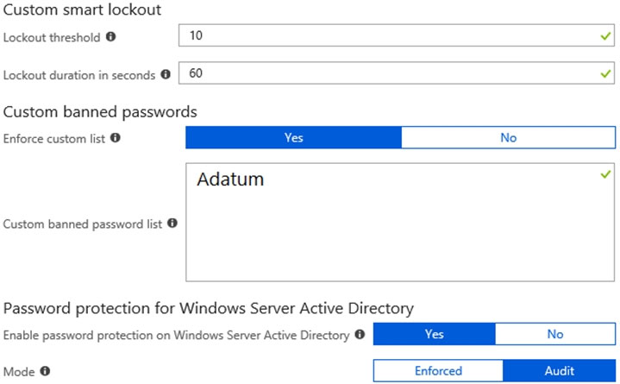

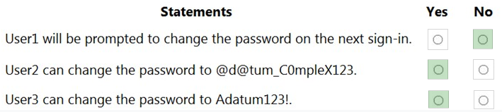

Audit modunda oldugu icin yalnizca event olusturur.

65. You have an Azure Active Directory (Azure AD) tenant that contains a user named Admin1. Admin1 is assigned the Application developer role.  
You purchase a cloud app named App1 and register App1 in Azure AD.  
Admin1 reports that the option to enable token encryption for App1 is unavailable.  
You need to ensure that Admin1 can enable token encryption for App1 in the Azure portal.  
What should you do?

* A. Upload a certificate for App1. **Most Voted**
* B. Modify the API permissions of App1.
* C. Add App1 as an enterprise application. **Most Voted**
* D. Assign Admin1 the Cloud application administrator role.

67. You have an Azure subscription named Subscription1 that contains the resources shown in the following table.  
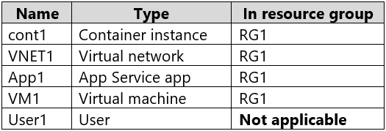  
You create a custom RBAC role in Subscription1 by using the following JSON file.  
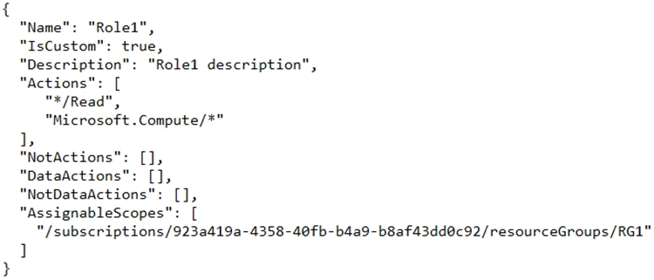  
You assign Role1 to User1 on RG1.

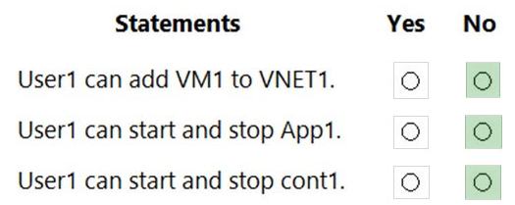

69. You have a Microsoft 365 tenant that uses an Azure Active Directory (Azure AD) tenant. The Azure AD tenant syncs to an on-premises Active Directory domain by using an instance of Azure AD Connect.  
You create a new Azure subscription.  
You discover that the synced on-premises user accounts cannot be assigned roles in the new subscription.  
You need to ensure that you can assign Azure and Microsoft 365 roles to the synced Azure AD user accounts.  
What should you do fist?

* A. Configure the Azure AD tenant used by the new subscription to use pass-through authentication.
* B. Configure the Azure AD tenant used by the new subscription to use federated authentication.
* C. Change the Azure AD tenant used by the new subscription.

We need to assign the Subscription on the tenant.

70. You have an Azure subscription that contains an app named App1. App1 has the app registration shown in the following table.  
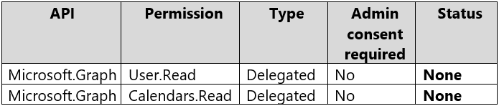  
You need to ensure that App1 can read all user calendars and create appointments. The solution must use the principle of least privilege.  
What should you do?

* A. Add a new Delegated API permission for Microsoft.Graph Calendars.ReadWrite.
* B. Add a new Application API permission for Microsoft.Graph Calendars.ReadWrite.
* The question is about reading and writing ALL user calendars. Delegated permissions only works for the logged in user.

71. You have an Azure Active Directory (Azure AD) tenant that contains the users shown in the following table.  
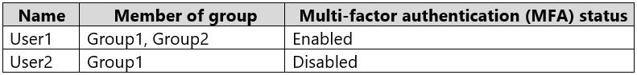  
You create and enforce an Azure AD Identity Protection sign-in risk policy that has the following settings:  
✑ Assignments: Include Group1, exclude Group2  
✑ Conditions: Sign-in risk level: Low and above  
✑ Access: Allow access, Require multi-factor authentication  
You need to identify what occurs when the users sign in to Azure AD.  
What should you identify for each user? To answer, select the appropriate options in the answer area.

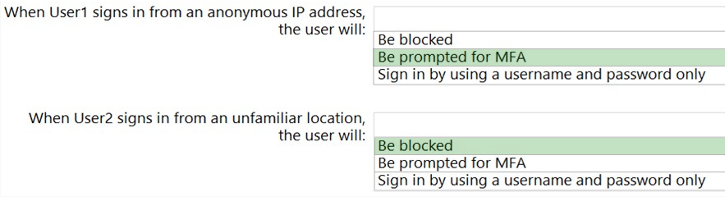

User1 - is excluded but user1 MFA is Enabled Exclusion will take precedence. Ans: MFA will be prompted User2 - is include and user meet the above threshold for sign-in risk level: low and above therefor user account will be blocked. Note: If you target this policy to a user that hasn't registered for MFA. Their access will be blocked

72. You have an Azure subscription that contains an Azure SQL database named SQL1.  
You plan to deploy a web app named App1.  
You need to provide App1 with read and write access to SQL1. The solution must meet the following requirements:  
✑ Provide App1 with access to SQL1 without storing a password.  
✑ Use the principle of least privilege.  
✑ Minimize administrative effort.  
Which type of account should App1 use to access SQL1, and which database roles should you assign to App1? To answer, select the appropriate options in the answer area.

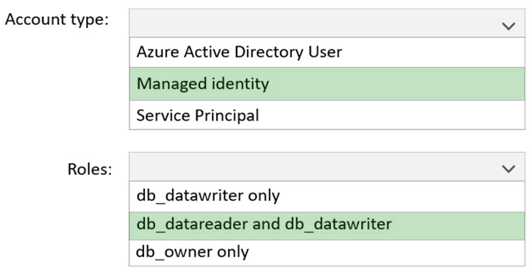

73. You have an Azure Active Directory (Azure AD) tenant that contains two users named User1 and User2 and a registered app named App1.  
You create an app-specific role named Role1.  
You need to assign Role1 to User1 and enable User2 to request access to App1.  
Which two settings should you modify? To answer, select the appropriate settings in the answer area.

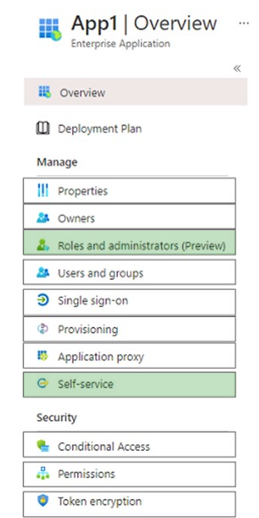

Box 1: Roles and administrators -  
Here you will find Role1 and be able to assign User1 to the role.  
Box 2: Self Service -  
Under Self Service, there is an option to ג€Allow users to request access to this applicationג€.

78. You have an Azure subscription that contains a storage account named storage1 and two web apps named app1 and app2.  
Both apps will write data to storage1.  
You need to ensure that each app can read only the data that it has written.  
What should you do?

* A. Provide each app with a system-assigned identity and configure storage1 to use Azure AD User account authentication.
* B. Provide each app with a separate Storage account key and configure the app to send the key with each request.
* C. Provide each app with a user-managed identity and configure storage1 to use Azure AD User account authentication.
* D. Provide each app with a unique Base64-encoded AES-256 encryption key and configure the app to send the key with each request.

79. You have an Azure subscription that contains an Azure Files share named share1 and a user named User1. Identity-based authentication is configured for share1.  
User1 attempts to access share1 from a Windows 10 device by using SMB.  
Which type of token will Azure Files use to authorize the request?

* A. OAuth 2.0
* B. JSON Web Token (JWT)
* C. SAML
* D. Kerberos

Supports Kerberos authentication with AD with AES 256 encryption (recommended) and RC4-HMAC.  
Note: Kerberos is an authentication protocol that is used to verify the identity of a user or host.

80. The custom roles will be used to perform the following tasks:  
  
• Members of Role1 will manage application security groups.  
• Members of Role2 will manage Azure Bastion.  
  
You need to add permissions to the custom roles.  
  
Which resource provider should you use for each role? To answer, drag the appropriate resource providers to the correct roles. Each resource provider may be used, more than once, or not at all. You may need to drag the split bar between panes or scroll to view content.

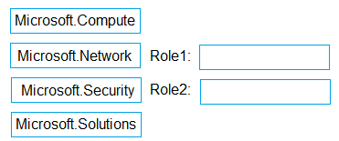

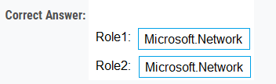

83. You have an Azure subscription that contains the resources shown in the following table.  
  
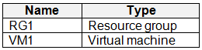  
  
You perform the following tasks:  
  
• Create a managed identity named Managed1.  
• Create a Microsoft 365 group named Group1.  
• Register an enterprise application named App1.  
• Enable a system-assigned managed identity for VM1.  
  
You need to identify which service principals were created and which identities can be assigned the Reader role for RG1.  
  
What should you identify? To answer, select the appropriate options in the answer area.

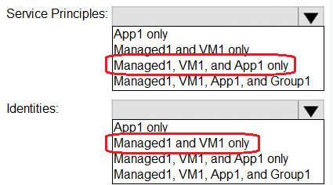

83. You have an Azure Active directory tenant that syncs with an Active Directory Domain Services (AD DS) domain.  
  
You plan to create an Azure file share that will contain folders and files.  
  
Which identity store can you use to assign permissions to the Azure file share and folders within the share? To answer, select the appropriate options in the answer area.

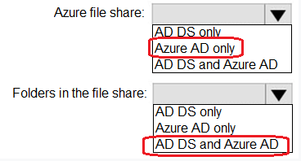

85. You have an Azure Active Directory (Azure AD) tenant that contains 500 users and an administrative unit named AU1.  
  
From the Azure Active Directory admin center, you plan to add the users to AU1 by using Bulk add members.  
  
You need to create and upload a file for the bulk add.  
  
What should you include in the file?

* A. only the display name of each user
* B. only the user principal name (UPN) of each user
* C. only the user principal name (UPN) and display name of each user

89. You have an Azure subscription that contains the resources shown in the following table.  
  
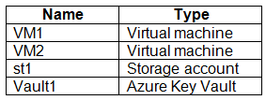  
  
You plan to perform the following actions:  
  
• Deploy a new app named App1 that will require access to Vault1.  
• Configure a shared identity for VM1 and VM2 to access st1.  
  
You need to configure identities for each requirement. The solution must minimize administrative effort.  
  
Which type of identity should you configure for each requirement? 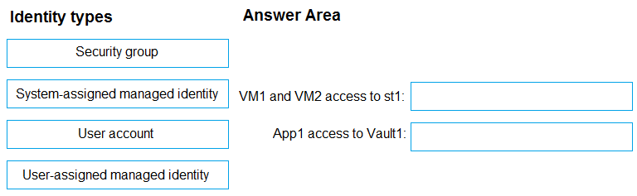

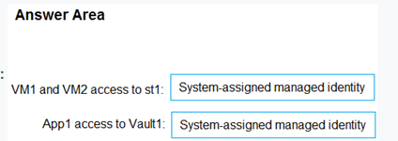

90. You have an Azure AD tenant. The tenant contains users that are assigned Azure AD Premium P2 licenses.  
You have a partner company that has a domain named fabrikam.com. The fabrikam.com domain contains a user named User1. User1 has an email address of user1@fabrikam.com  
You need to provide User1 with access to the resources in the tenant. The solution must meet the following requirements:  
  
• User1 must be able to sign in by using the user1@fabrikam.com credentials.  
• You must be able to grant User1 access to the resources in the tenant.  
• Administrative effort must be minimized.  
  
What should you do?

* A. Create a user account for User1.
* B. To the tenant, add fabrikam.com as a custom domain.
* C. Create an invite for User1.
* 93. You have an Azure subscription that contains a storage account named contoso2023.  
  You need to perform the following tasks:  
  • Verify that identity-based authentication over SMB is enabled.  
  • Only grant users access to contoso2023 in the year 2023.  
  Which two settings should you use? To answer, select the appropriate settings in the answer area.
* 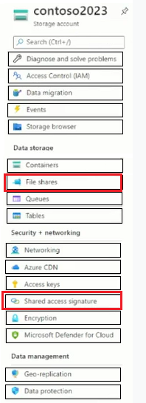

**TEST 3**

9. You create resources in an Azure subscription as shown in the following table.  
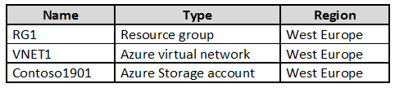  
VNET1 contains two subnets named Subnet1 and Subnet2. Subnet1 has a network ID of 10.0.0.0/24. Subnet2 has a network ID of 10.1.1.0/24.  
Contoso1901 is configured as shown in the exhibit. (Click the Exhibit tab.)  
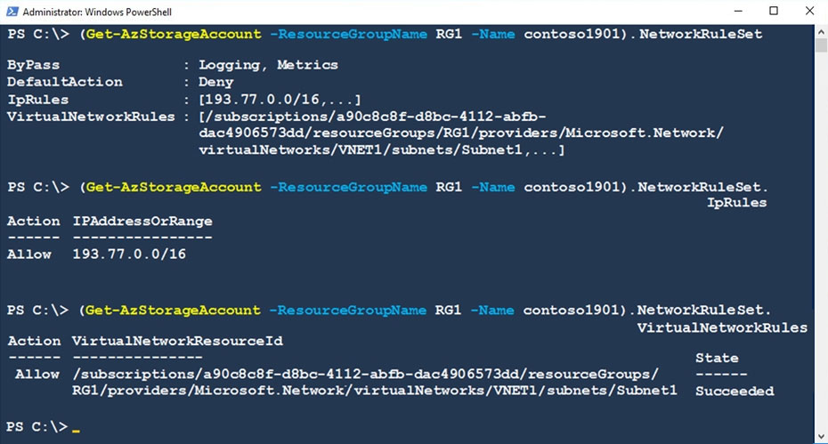

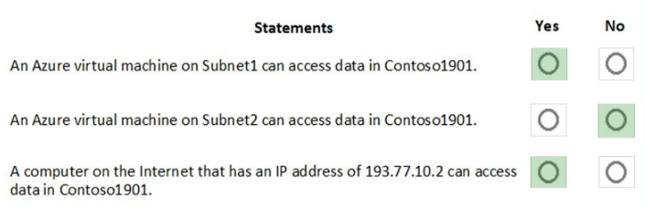

14. You have an Azure subscription that contains the virtual networks shown in the following table.  
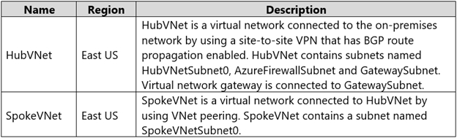  
The Azure virtual machines on SpokeVNetSubnet0 can communicate with the computers on the on-premises network.  
You plan to deploy an Azure firewall to HubVNet.  
You create the following two routing tables:  
✑ RT1: Includes a user-defined route that points to the private IP address of the Azure firewall as a next hop address  
✑ RT2: Disables BGP route propagation and defines the private IP address of the Azure firewall as the default gateway  
You need to ensure that traffic between SpokeVNetSubnet0 and the on-premises network flows through the Azure firewall.  
To which subnet should you associate each route table? To answer, drag the appropriate subnets to the correct route tables.

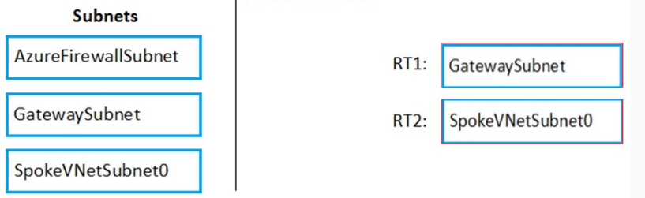

15. You have an Azure subscription. The subscription contains Azure virtual machines that run Windows Server 2016.  
You need to implement a policy to ensure that each virtual machine has a custom antimalware virtual machine extension installed.  
How should you complete the policy? To answer, select the appropriate options in the answer area.

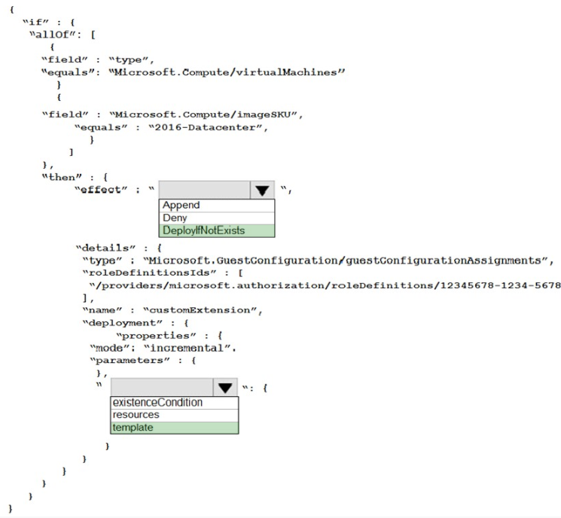

16. You are configuring an Azure Kubernetes Service (AKS) cluster that will connect to an Azure Container Registry.  
You need to use the auto-generated service principal to authenticate to the Azure Container Registry.  
What should you create?

* A. an Azure Active Directory (Azure AD) group
* B. an Azure Active Directory (Azure AD) role assignment
* C. an Azure Active Directory (Azure AD) user

17. You have an Azure subscription that contains the Azure virtual machines shown in the following table.  
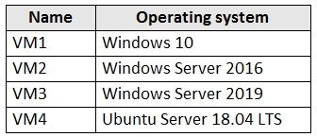  
You create an MDM Security Baseline profile named Profile1.  
You need to identify to which virtual machines Profile1 can be applied.  
Which virtual machines should you identify?

* A. VM1 only

MDM Security Baseline profile: Servers are not Mobile, and MDM is Mobile Device Management, so the only answer to choose here is Windows 10 as it can be installed on a laptop making it Mobile. HOPE this helps.

20. You need to ensure that a user named Danny1234578 can sign in to any SQL database on a Microsoft SQL server named web1234578 by using SQL Server  
Management Studio (SSMS) and Azure Active Directory (Azure AD) credentials.  
To complete this task, sign in to the Azure portal.

**Correct Answer:** *See the explanation below.*  
You need to provision an Azure AD Admin for the SQL Server.  
1. In the Azure portal, type SQL Server in the search box, select SQL Server from the search results then select the server named web1234578. Alternatively, browse to SQL Server in the left navigation pane.  
2. In the SQL Server properties page, click on Active Directory Admin.  
3. Click the Set Admin button.  
4. In the Add Admin window, search for and select Danny1234578.  
5. Click the Select button to add Danny1234578.  
6. Click the Save button to save the changes.

21. You need to configure a Microsoft SQL server named Web1234578 only to accept connections from the Subnet0 subnet on the VNET01 virtual network.  
To complete this task, sign in to the Azure portal.

You need to allow access to Azure services and configure a virtual network rule for the SQL Server.  
1. In the Azure portal, type SQL Server in the search box, select SQL Server from the search results then select the server named web1234578. Alternatively, browse to SQL Server in the left navigation pane.  
2. In the properties of the SQL Server, click Firewalls and virtual networks.  
3. In the Virtual networks section, click on Add existing. This will open the Create/Update virtual network rule window.  
4. Give the rule a name such as Allow_VNET01-Subnet0 (it doesn't matter what name you enter for the exam).  
5. In the Virtual network box, select VNET01.  
6. In the Subnet name box, select Subnet0.  
7. Click the OK button to save the rule.  
8. Back in the Firewall / Virtual Networks window, set the Allow access to Azure services option to On.

23. You have an Azure subscription that contains the virtual machines shown in the following table.  
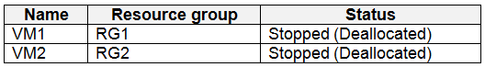  
You create the Azure policies shown in the following table.  
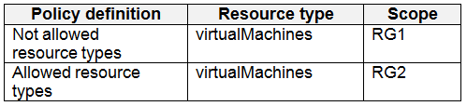  
You create the resource locks shown in the following table.  
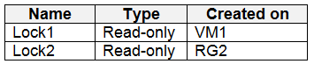  
For each of the following statements, select Yes if the statement is true. Otherwise, select No.  
NOTE: Each correct selection is worth one point.  
Hot Area:  
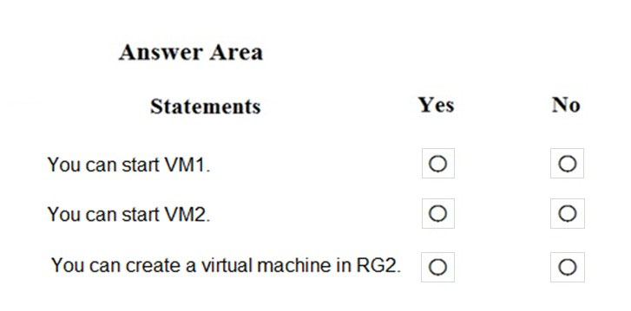

No- No- No

24. You have an Azure subscription that contains an Azure Active Directory (Azure AD) tenant named contoso.com. The tenant contains the users shown in the following table.  
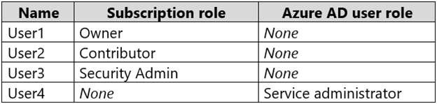  
You create a resource group named RG1.  
Which users can modify the permissions for RG1 and which users can create virtual networks in RG1?

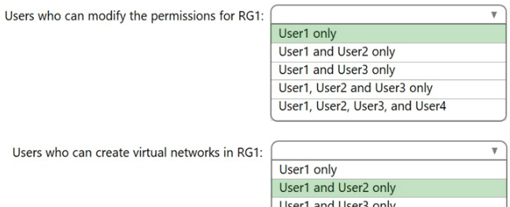

29. You have a file named File1.yaml that contains the following contents.  
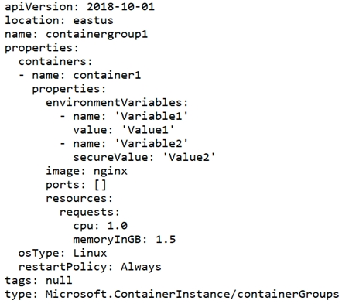  
You create an Azure container instance named container1 by using File1.yaml.  
You need to identify where you can access the values of Variable1 and Variable2.

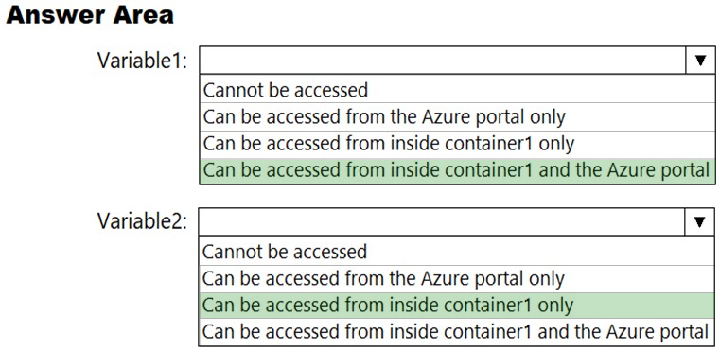

30. You have an Azure subscription that contains a virtual network. The virtual network contains the subnets shown in the following table.  
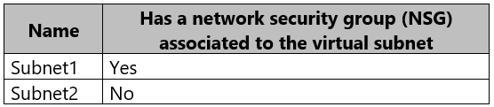  
The subscription contains the virtual machines shown in the following table.  
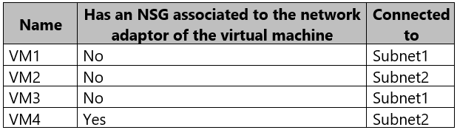  
You enable just in time (JIT) VM access for all the virtual machines.  
You need to identify which virtual machines are protected by JIT.  
Which virtual machines should you identify?

* A. VM4 only
* B. VM1 and VM3 only
* C. VM1, VM3 and VM4 only

31. You have an Azure subscription that contains the virtual machines shown in the following table.  
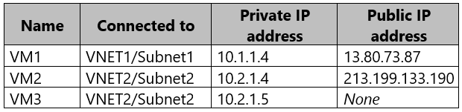  
Subnet1 and Subnet2 have a Microsoft.Storage service endpoint configured.  
You have an Azure Storage account named storageacc1 that is configured as shown in the following exhibit.  
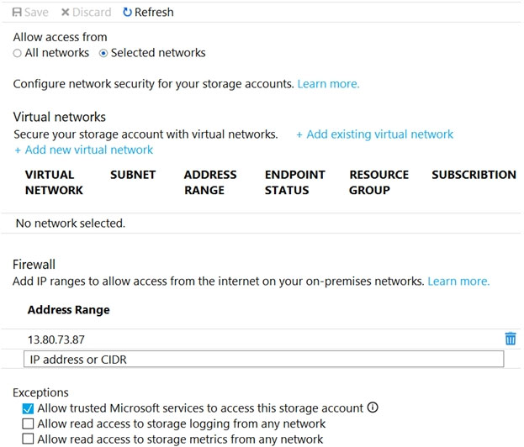

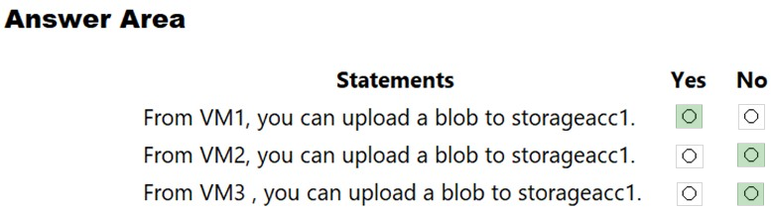

39. You are testing an Azure Kubernetes Service (AKS) cluster. The cluster is configured as shown in the exhibit. (Click the Exhibit tab.)  
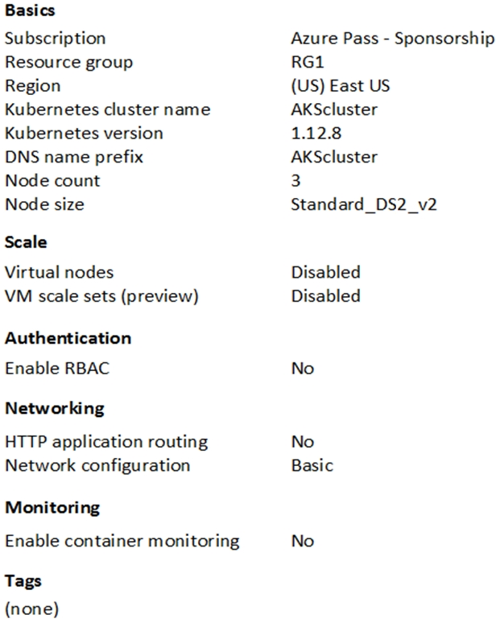  
You plan to deploy the cluster to production. You disable HTTP application routing.  
You need to implement application routing that will provide reverse proxy and TLS termination for AKS services by using a single IP address.  
What should you do?

* A. Create an AKS Ingress controller.

42. You have an Azure Active Directory (Azure AD) tenant named Contoso.com and an Azure Kubernetes Service (AKS) cluster AKS1.  
You discover that AKS1 cannot be accessed by using accounts from Contoso.com.  
You need to ensure AKS1 can be accessed by using accounts from Contoso.com. The solution must minimize administrative effort.  
What should you do first?

* A. From Azure, recreate AKS1.

44. From Azure Security Center, you create a custom alert rule.  
You need to configure which users will receive an email message when the alert is triggered.  
What should you do?

* A. From Azure Monitor, create an action group.

48. You have 15 Azure virtual machines in a resource group named RG1.  
All the virtual machines run identical applications.  
You need to prevent unauthorized applications and malware from running on the virtual machines.  
What should you do?

* A. Apply an Azure policy to RG1.
* B. From Azure Security Center, configure adaptive application controls.
* C. Configure Azure Active Directory (Azure AD) Identity Protection.
* D. Apply a resource lock to RG1.

51. You are configuring network connectivity for two Azure virtual networks named VNET1 and VNET2.  
You need to implement VPN gateways for the virtual networks to meet the following requirements:  
✑ VNET1 must have six site-to-site connections that use BGP.  
✑ VNET2 must have 12 site-to-site connections that use BGP.  
✑ Costs must be minimized.  
Which VPN gateway SKU should you use for each virtual network? To answer, drag the appropriate SKUs to the correct networks. Each SKU may be used once, more than once, or not at all.

**orrect Answer:** 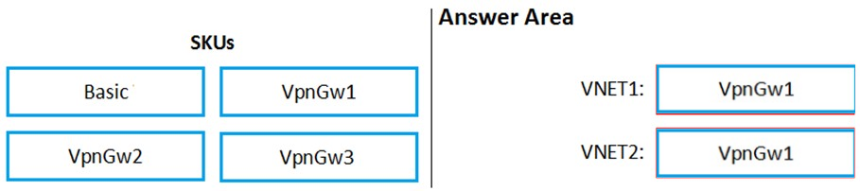

Basic are max 10 and no BGP.

53. You have an Azure subscription that contains a storage account named storage1 and several virtual machines. The storage account and virtual machines are in the same Azure region. The network configurations of the virtual machines are shown in the following table.  
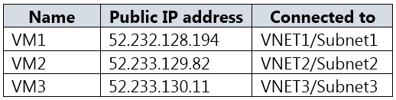  
The virtual network subnets have service endpoints defined as shown in the following table.  
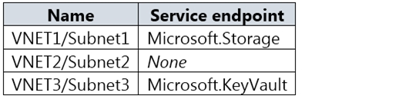  
You configure the following Firewall and virtual networks settings for storage1:  
✑ Allow access from: Selected networks  
✑ Virtual networks: VNET3\Subnet3  
Firewall `" Address range: 52.233.129.0/24

**Correct Answer:** 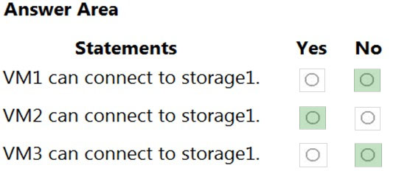  
Box 1: No -  
VNet1 has a service endpoint configure for Azure Storage. However, the Azure storage does not allow access from VNet1 or the public IP address of VM1.  
Box 2: Yes -  
VNet2 does not have a service endpoint configured. However, the Azure storage allows access from the public IP address of VM2.

Box 3: No -  
Azure storage allows access from VNet3. However, VNet3 does not have a service endpoint for Azure storage. The Azure storage also does not allow access from the public IP of VM3.

54. You plan to create an Azure Kubernetes Service (AKS) cluster in an Azure subscription.  
The manifest of the registered server application is shown in the following exhibit.  
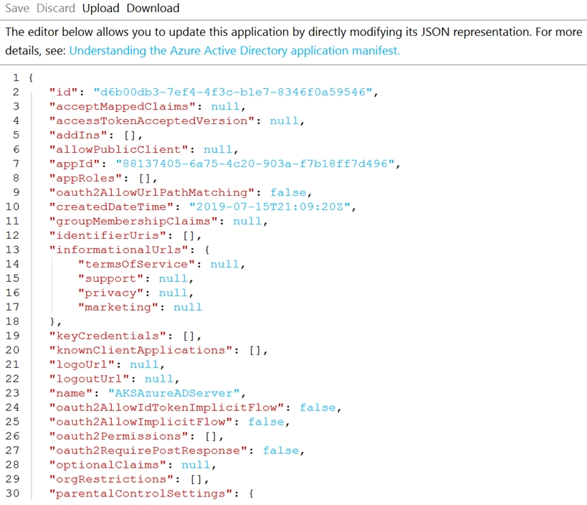  
You need to ensure that the AKS cluster and Azure Active Directory (Azure AD) are integrated.  
Which property should you modify in the manifest?

* A. accessTokenAcceptedVersion
* B. keyCredentials
* C. groupMembershipClaims

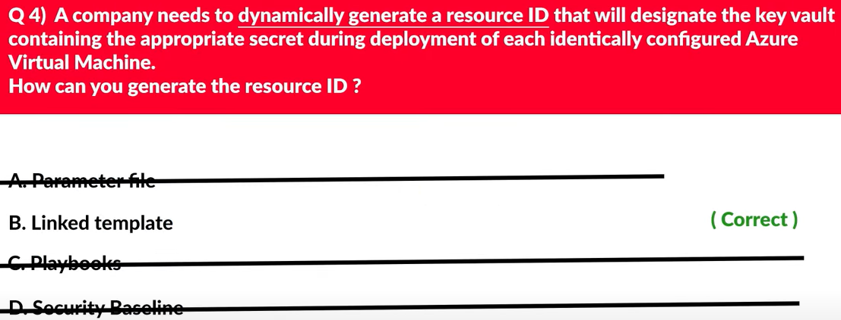

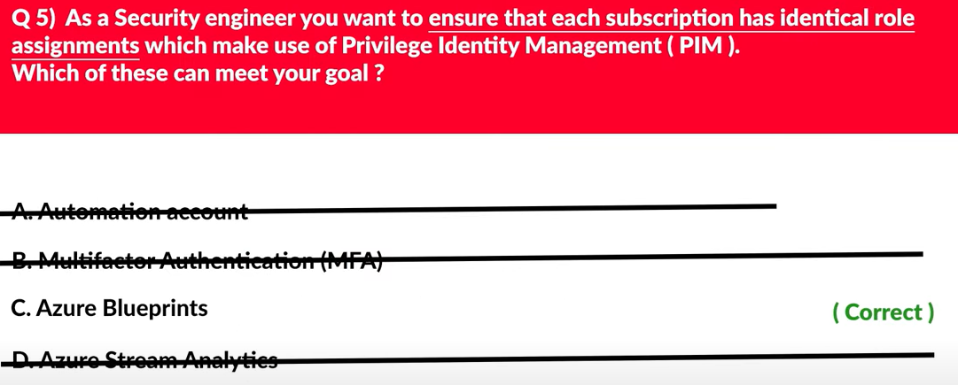

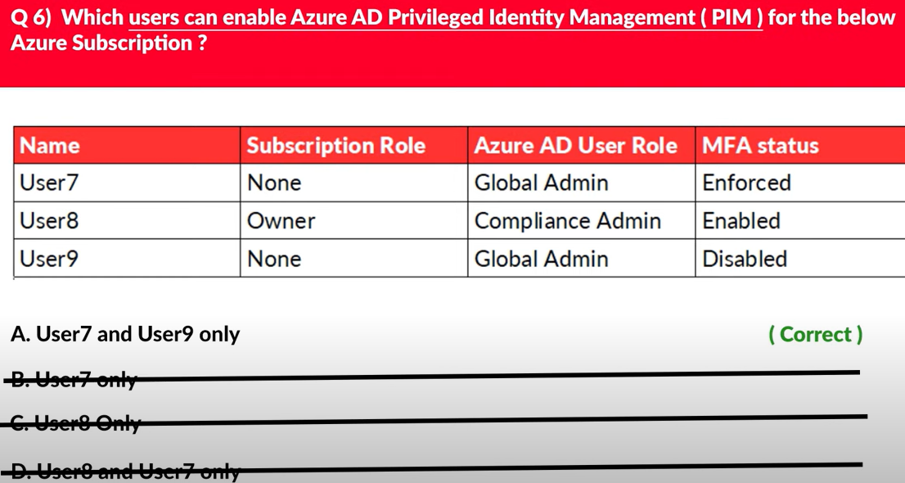

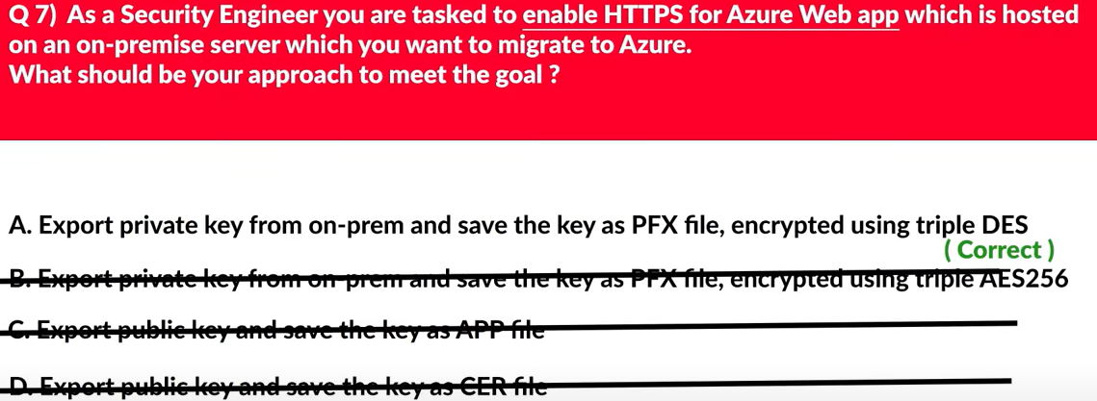

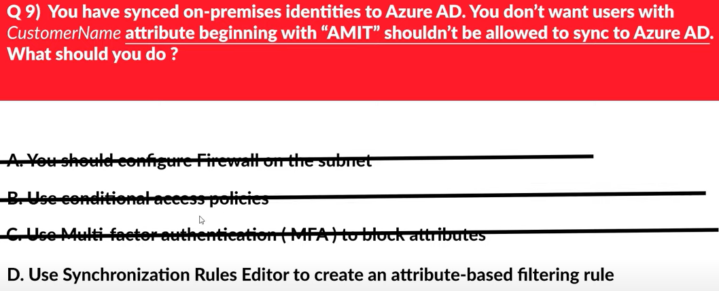

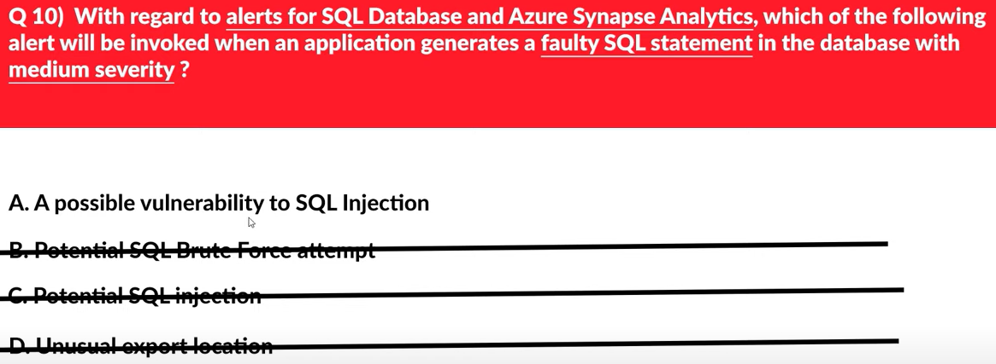

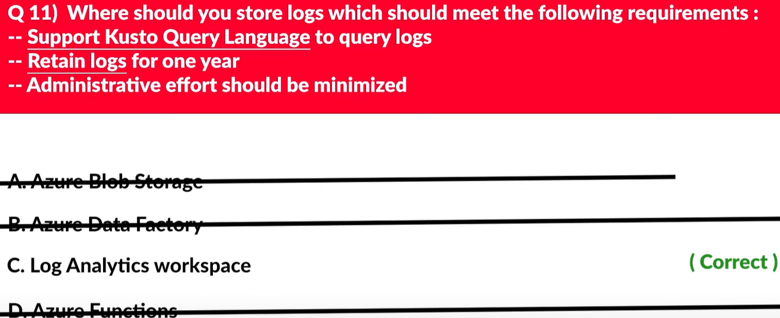

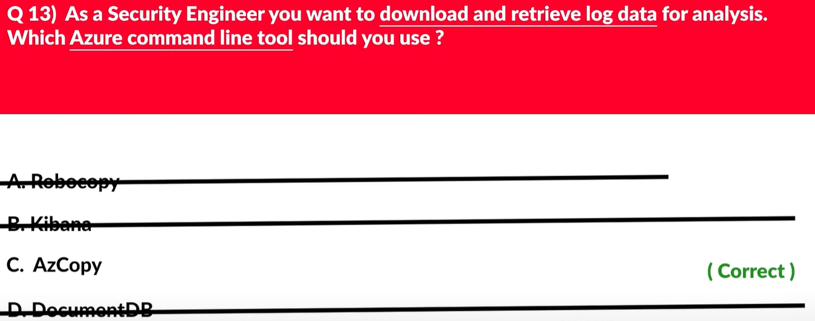

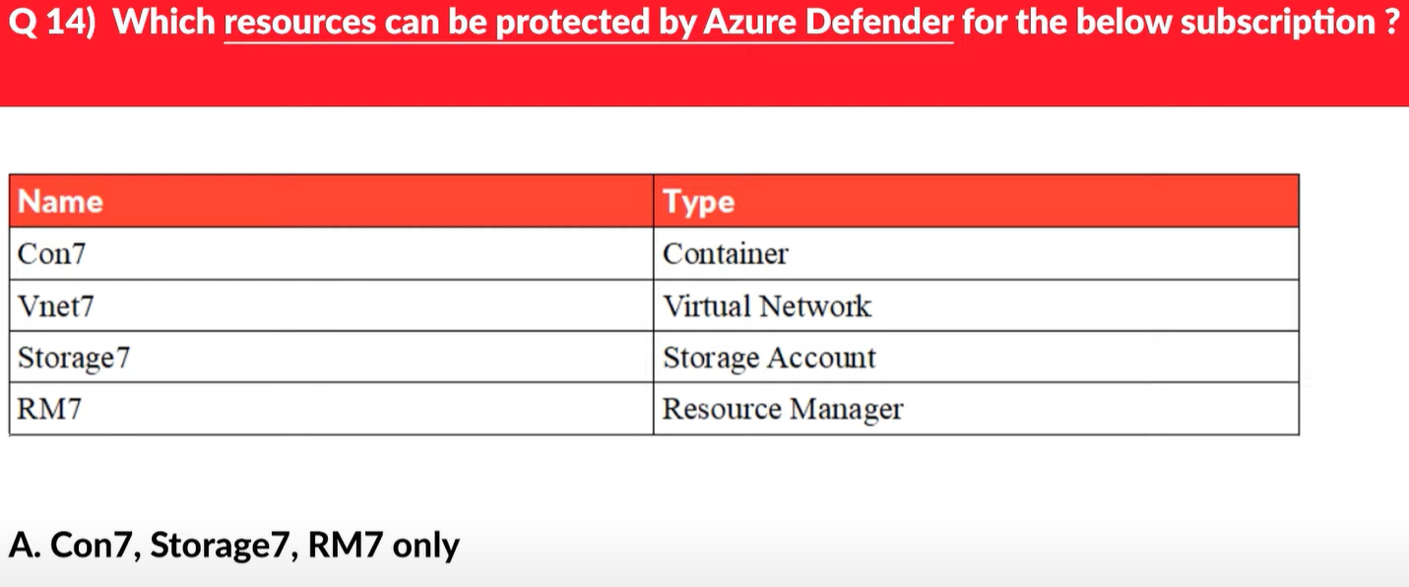

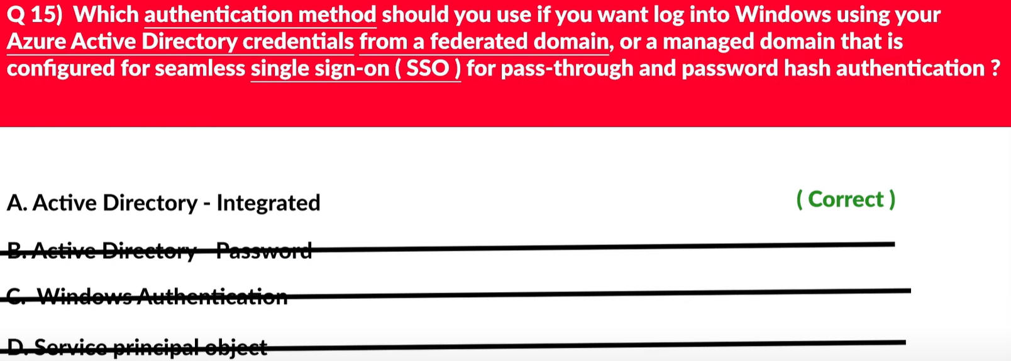

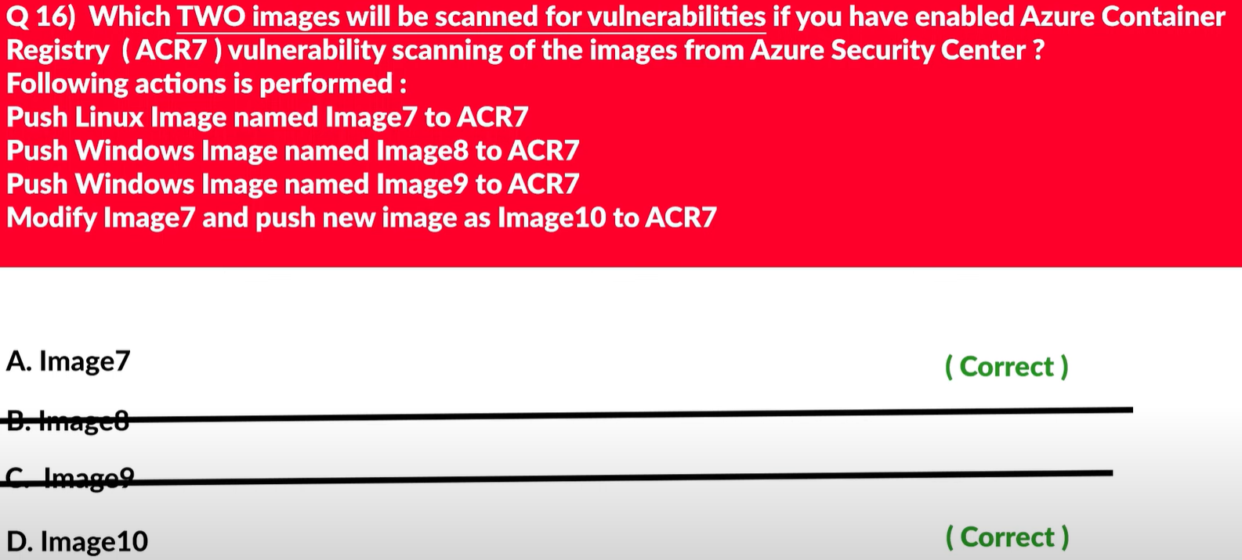

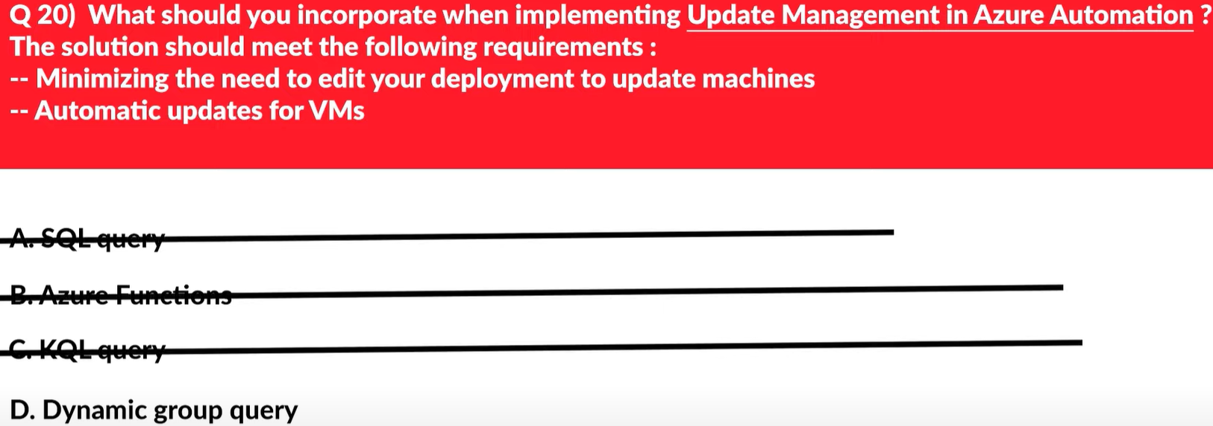

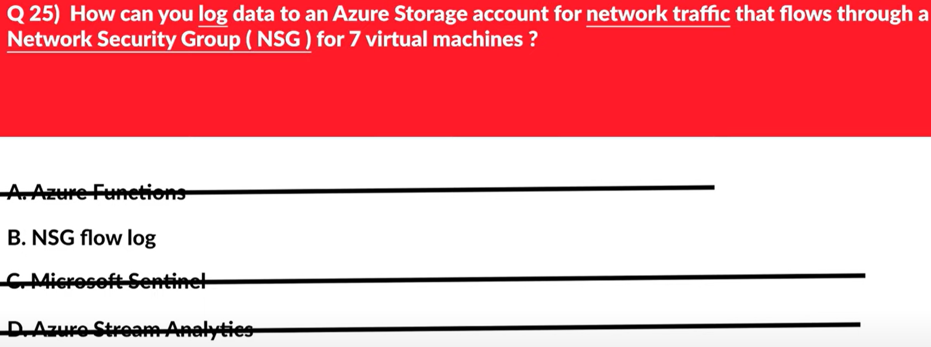

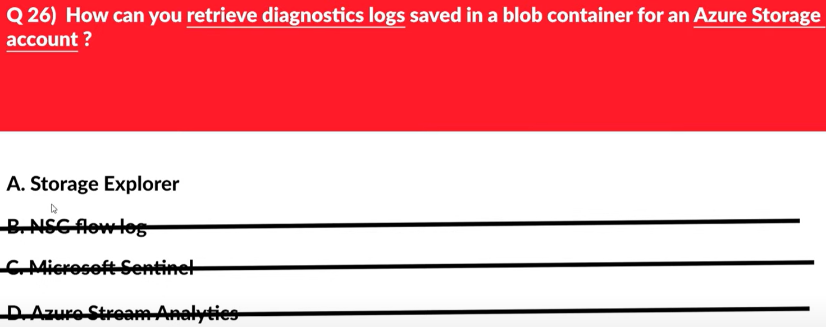

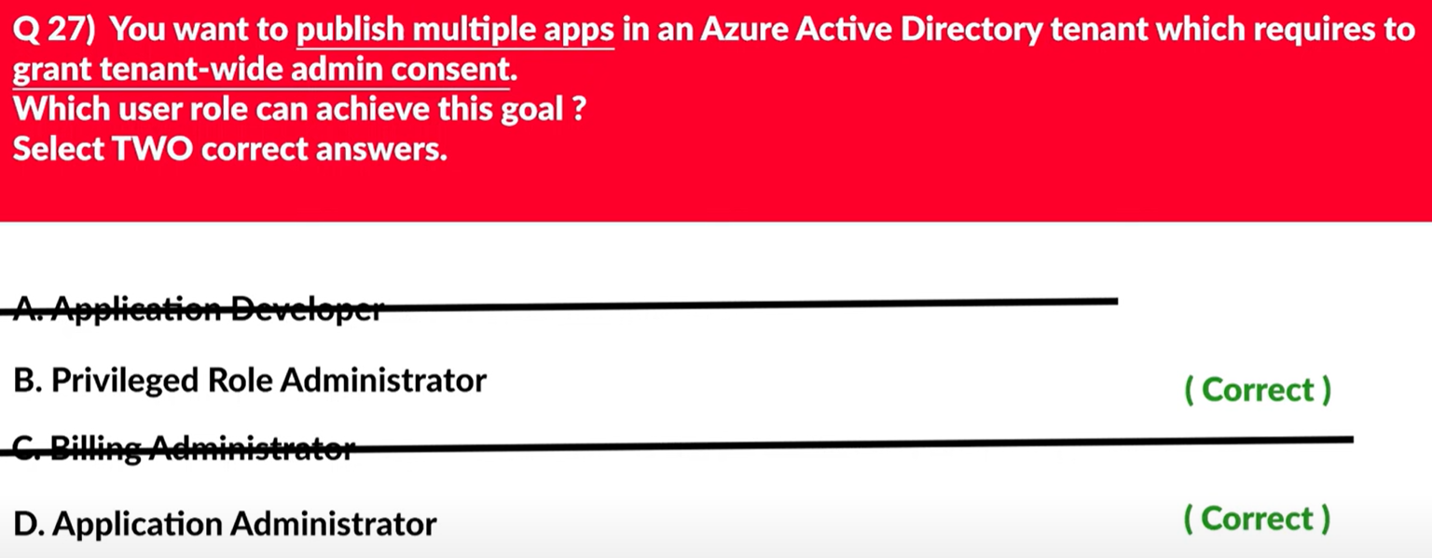

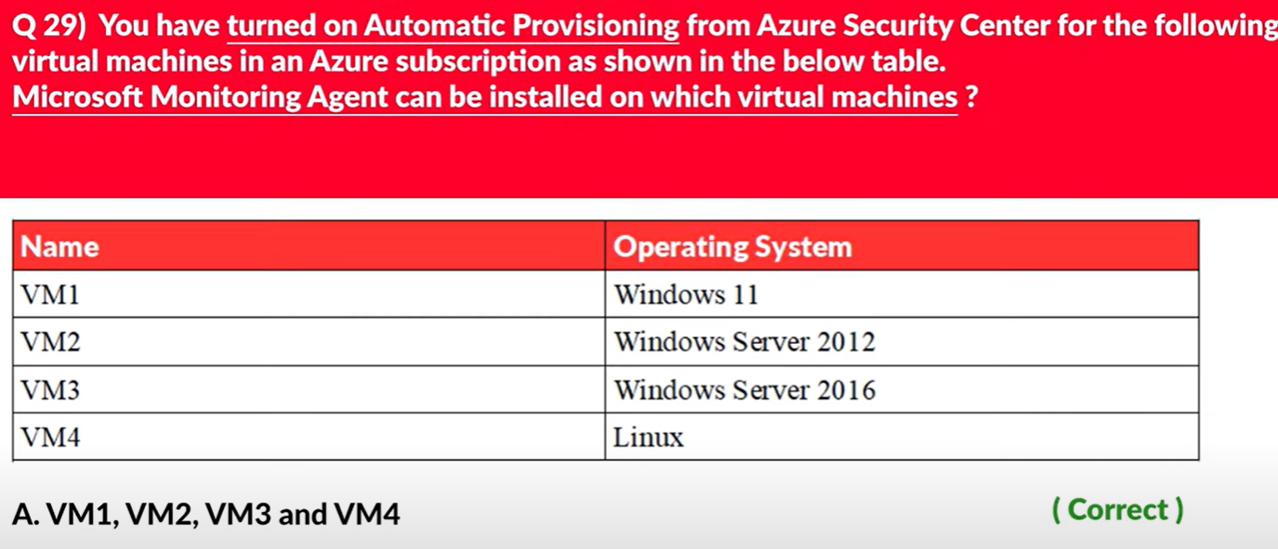

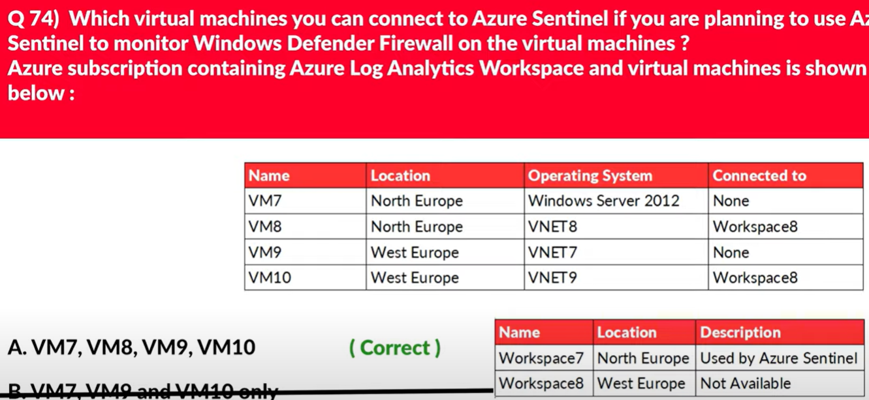

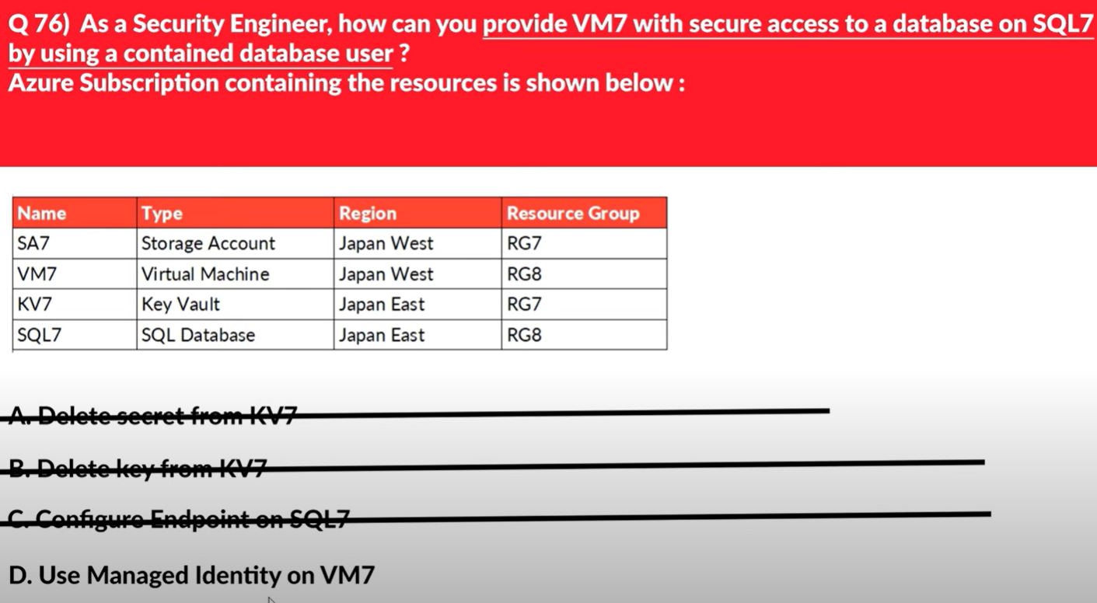

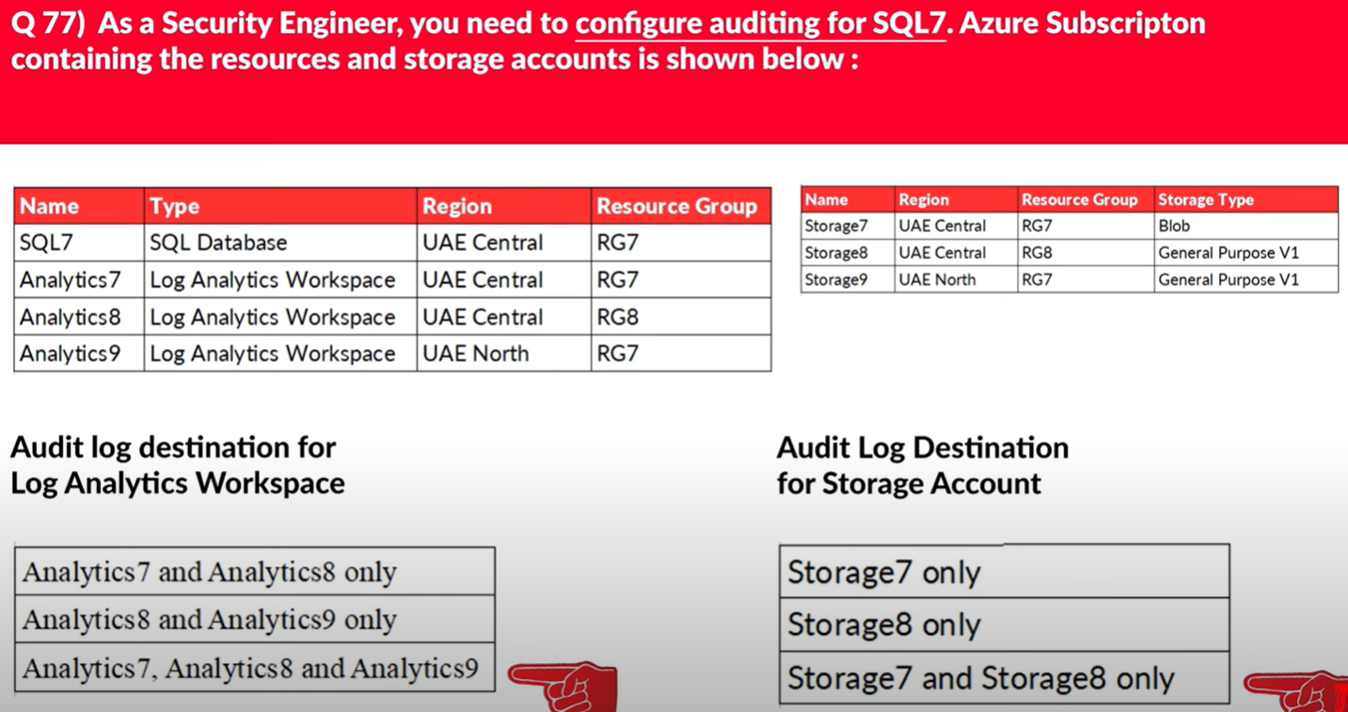

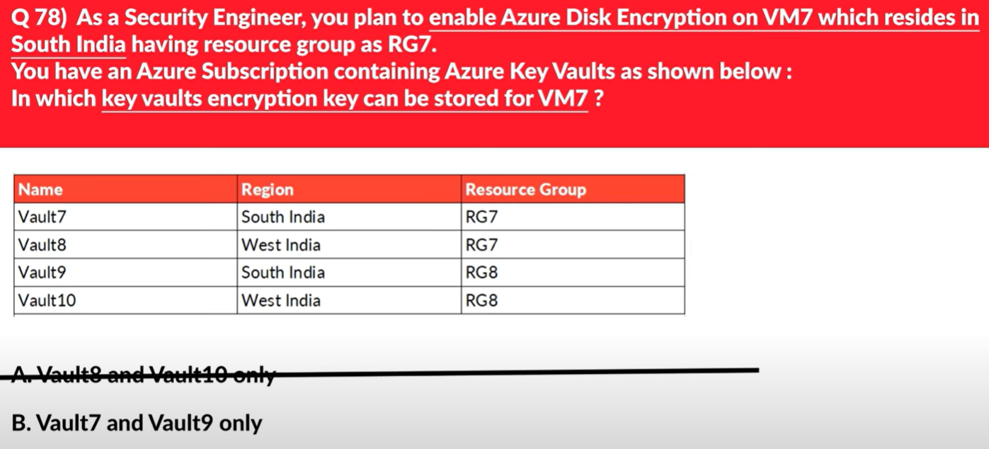

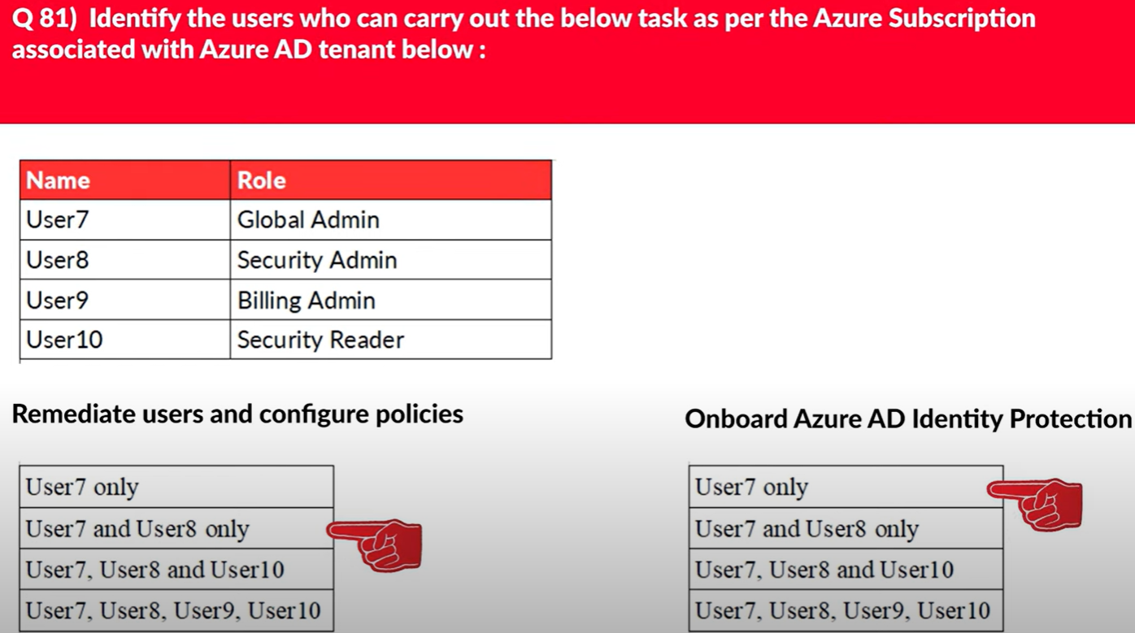

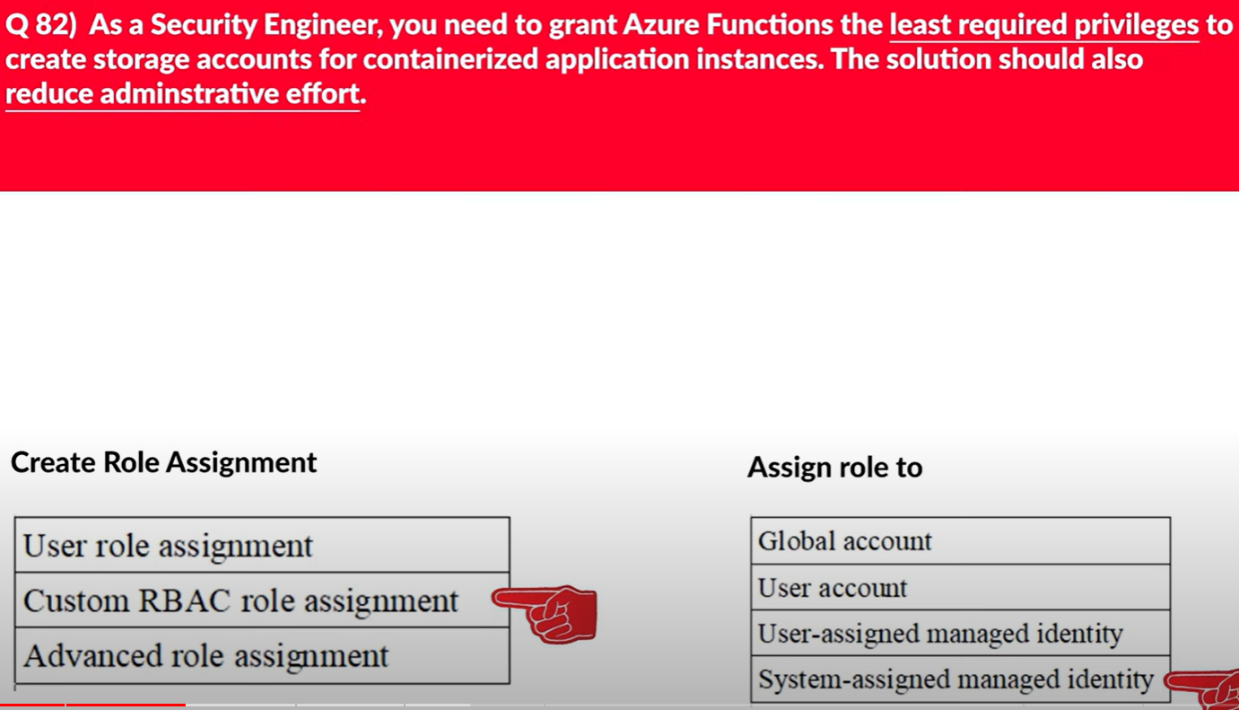

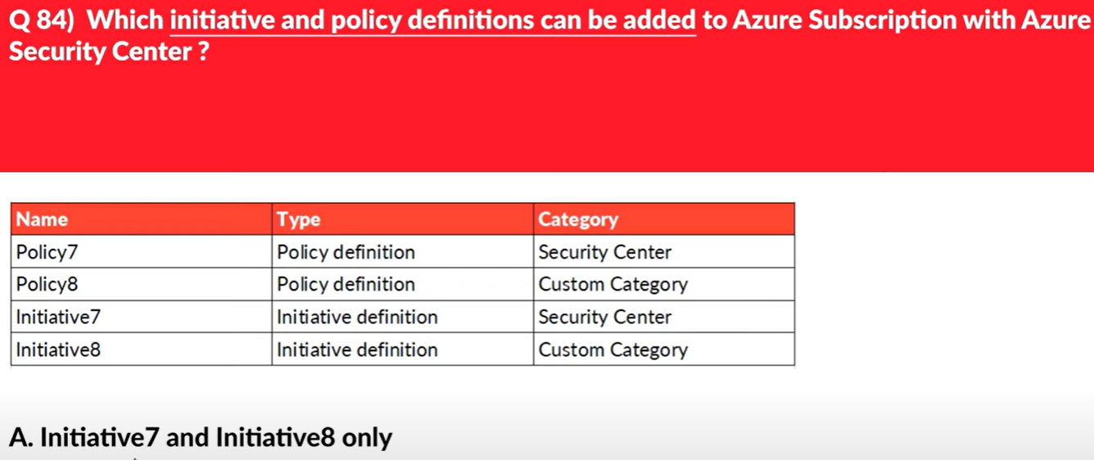

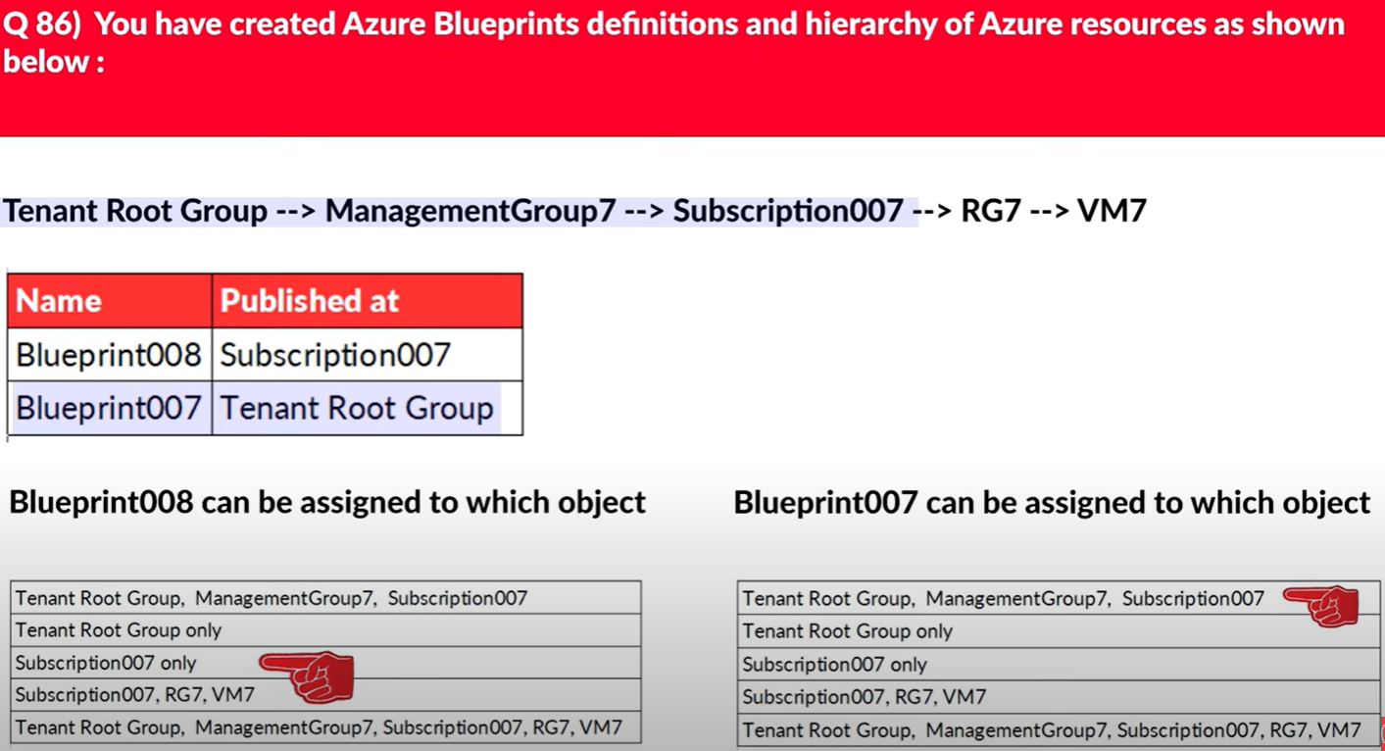

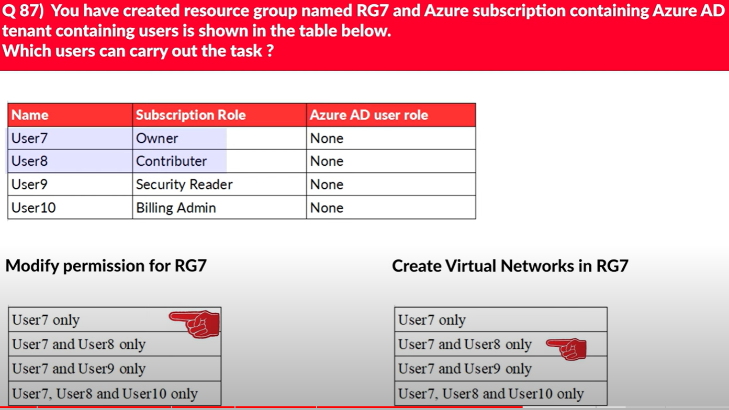

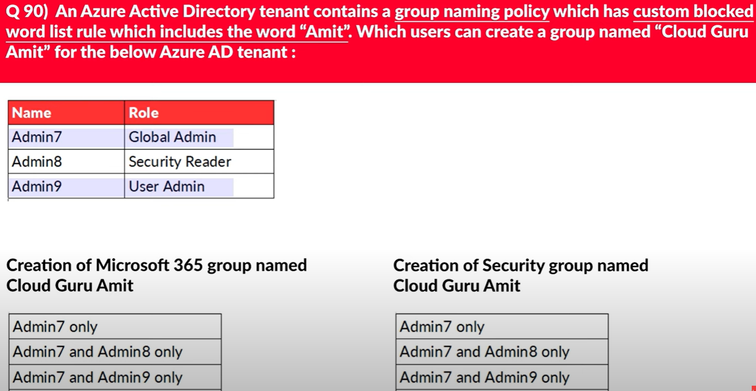

Ikisinde de 7, 9.

